**DIN Connector Soldering-Aid – The Potato Rev. 0**

**Module Description**

# Introduction

Soldering DIN connectors has never been real fun. Some people reported using a potato as soldering-aid. It is holding the connector in position and is cooling the pins while soldering to prevent the plastic body of the connector from melting.

But:

* Do you really want vegetables/food in your lab?
* Is it good to cool the pins of the connector, that is hard to solder, anyway?

It is also not clear, if there is an effect of the substances in a potato on the surface of the pins. Especially power connectors require a low impedance of the contact surfaces.

Pasi Lassila introduced me on Facebook to the idea of using a PCB as a DIN connector holder.

The goal of the development was to provide a solution, that holds the pins in place and that provides a variety of DIN connector configurations.

Those are:

* DIN8/270° (DIN 41526)
* DIN8/262° (aka “horseshoe”, DIN 41524)
* DIN7/270° (DIN 45329)
* DIN6/240° (DIN 45322)
* DIN5/360° (aka “dice”, DIN 41524)
* DIN4/216° (DIN41524)

The wide spread DIN5/180° fits on both DIN8 and the DIN7 footprint.

Further on, the PCB should serve as a cheat sheet for the pin numbers and some important pinouts in the retro computing world (especially Commodore computers).

According to the DIN standards, the pin diameter is 1.45mm. The drills on this board are 1.60mm. Thus, there is not a lot of friction when pulling out the connectors. An exception is the Belden/Hirschmann branded MAS 80 S (DIN8/262° horse shoe), which has a PIN diameter of 1.5mm. The PCB holds this connector with a medium high friction.

# Usage

* Stack two of the PCBs with the help of four screws (M3x12, e.g. DIN 7985) and 12 Nuts (M3, e.g. DIN 934)
* Put the stack with the inserted connector horizontally on the workbench while soldering
* Use a helping hand for holding the cable (covering the crocodile clamps with a shrinkable sleeve to prevent denting the cable)
* Solder one wire after the other

The soldering method is a recommendation. Different methods (“The Potato” clamped in different ways or on the workbench) were tried out. Horizontally on the workbench seems to be the best way, since the PCB can be rotated easily to access the solder joints from all directions.

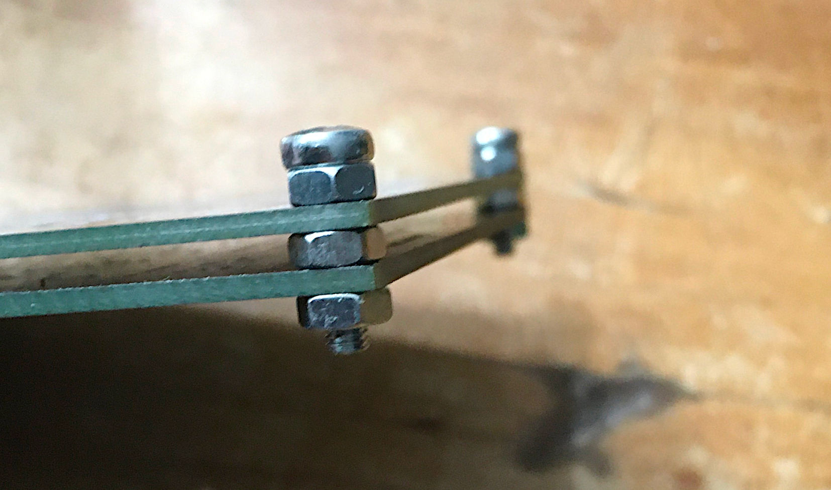

Figure 1: Method of stacking the PCBs with using nuts as spacers

# Test

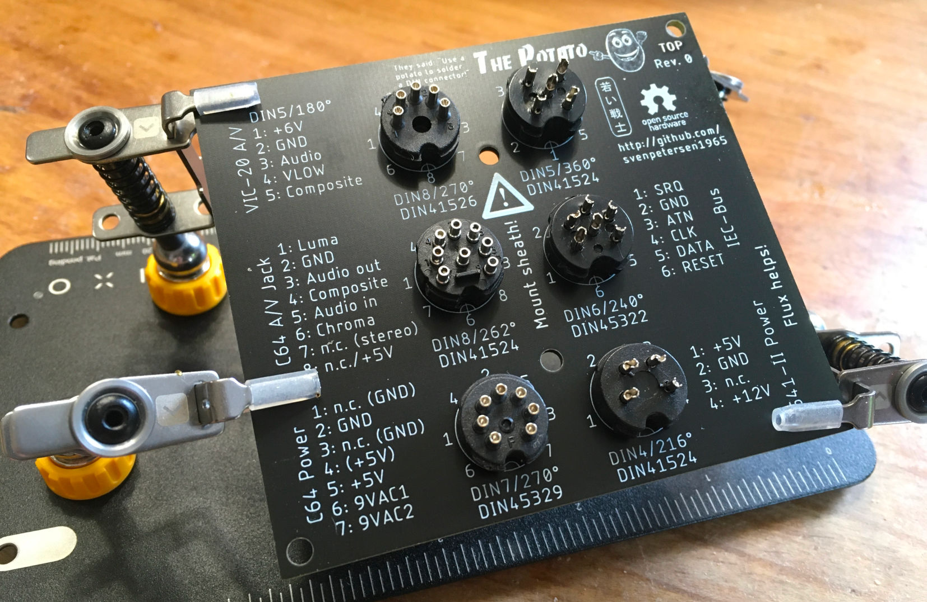

Figure 2: Test: Fitting all available connector types

The DIN8/270° was not available at the time of test.

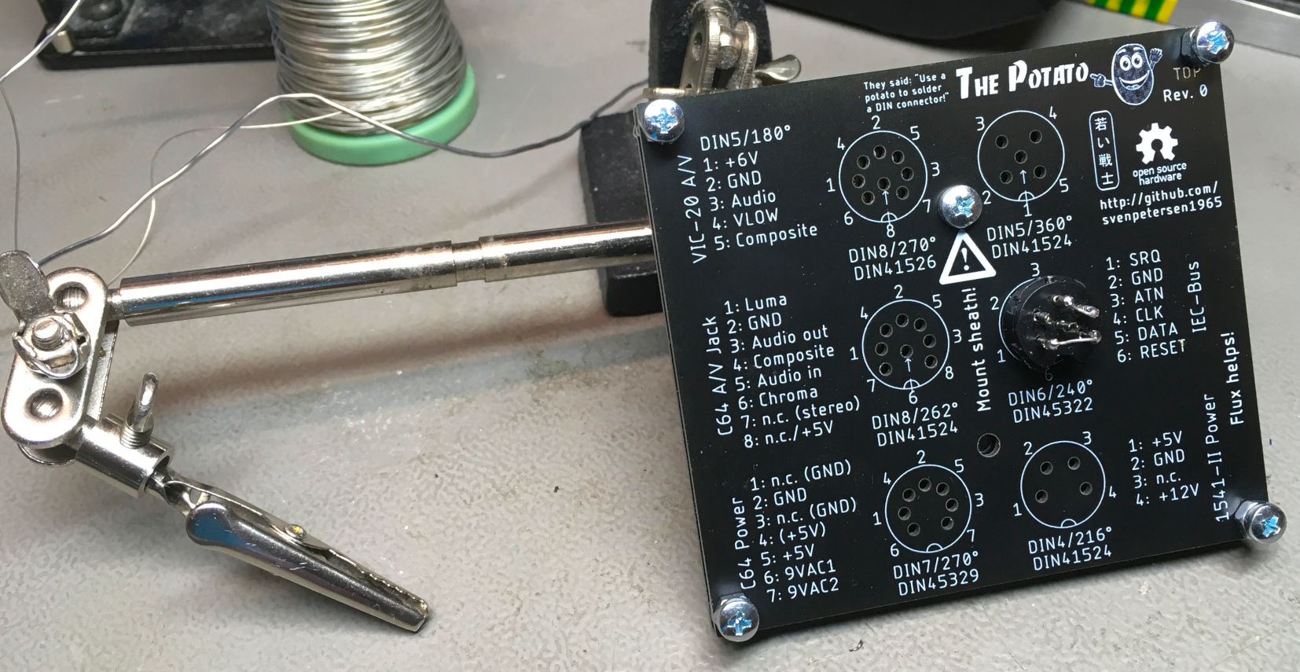

Figure 3: Soldering while the Potato is held with a helping hand

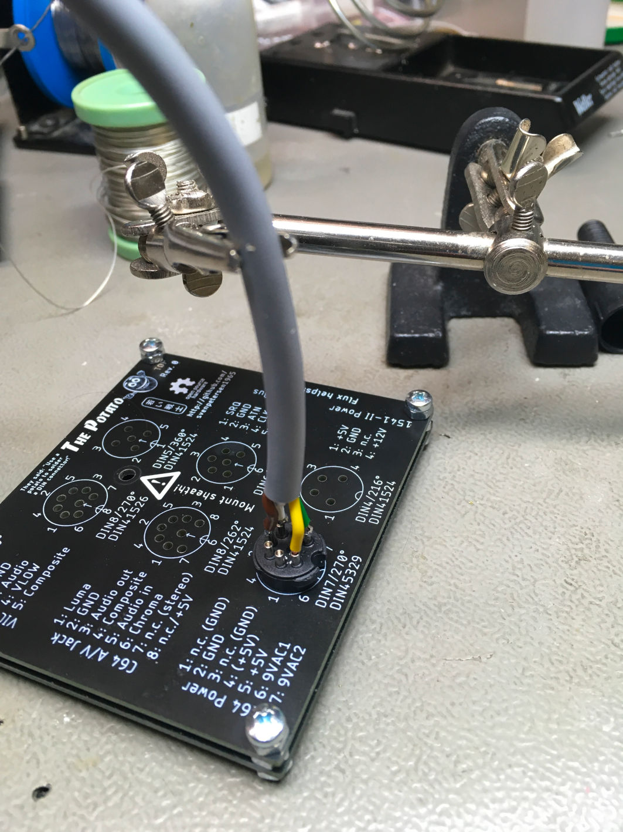

Figure 4: Test with the Potato on the workbench (best option)

# Dimensions

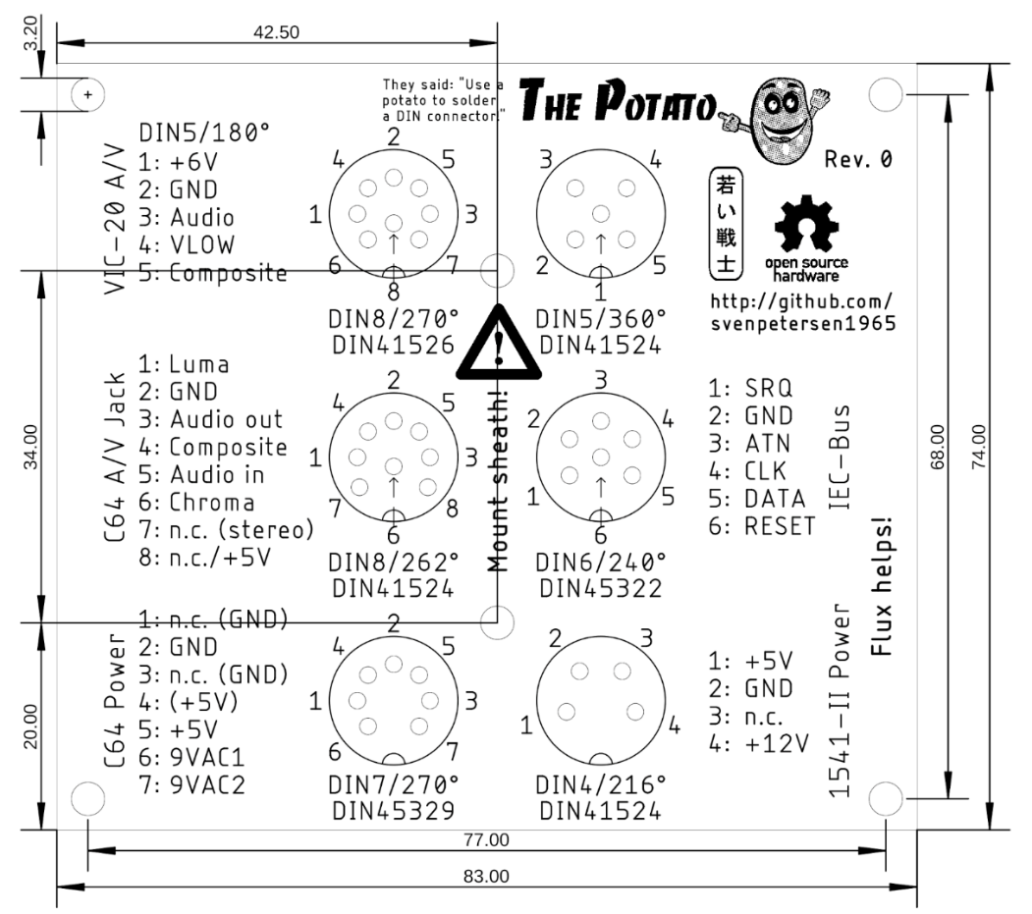

Figure 5: dimensions of the PCB

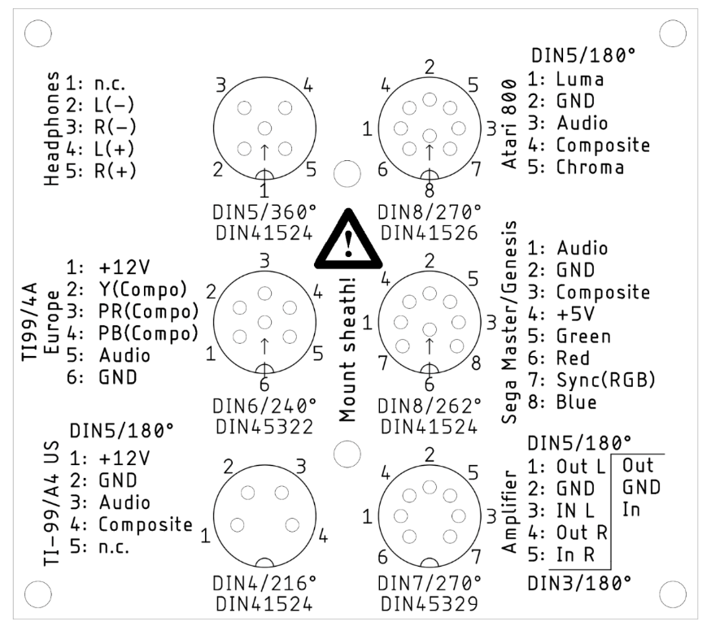

Figure 6: Bottom side of the PCB

# Disclaimer

I have carefully compared the different pinnings with the source, that I have found, but I cannot verify each source. Use on own risk.

Soldering DIN connectors is never fun and The Potato does not make it fun, but it helps holding the connector body while soldering. And it does it quite a bit nicer, than just using a helping hand. It holds the pins in place.

# Revision History

## Rev. 0

* Tested, all connectors could be inserted properly